Data Technician Workbook
Week 3: Databases & SQL

Name: Robert Anderson
Course Date: 13th July 2026
Table of contents
Day 1: Task 1 3
Day 1: Task 2 3
Day 3: Task 1 4
Day 4: Task 1: Written 6
Day 4: Task 2: PostgreSQL Practical 9
Course Notes 19
Additional Information 19

Day 1: Task 1

Place/paste your ERD image here:

Next,

Please research and complete the questions below relating to key concepts of databases.

What is a primary key? | The primary key is used to identify each row and will have secondary rows related to it. For example, a 'sales' primary key may have secondary keys such as units sold, dates, average cost etc.
How does this differ from a secondary key? | There can only be one primary key whilst you can have multiple secondary keys. For example, a primary key might be 'Customer ID' the secondary keys to this could be email, phone number, address etc offering multiple fields.  Medium.com
How are primary and foreign keys related? | Primary and foreign keys are related to each other as they create the links from one table to another. A foreign key will used the primary key from another table to present the required information.
Provide a real-world example of a one-to-one relationship | An example of this would be a national insurance number. This code is used by the government to identify each individual from another who could have the same name, date of birth etc and is a unique code. Another example would be a passport using very similar reason.
Provide a real-world example of a one-to-many relationship | The first instance that came to mind is a football team working under a manager. There is only one manager whilst there will be many players under their care. The same could be said for most businesses
Provide a real-world example of a many-to-many relationship | A real world example of this would be a bank and its customers. Many people will have multiple accounts with the same bank, or they may have accounts with multiple banks. Banks will have many customers thus making this a many to many relationship.  Many to many relationship guidance

Day 1: Task 2

Please research and complete the questions below relating to key concepts of databases.

What is the difference between a relational and non-relational database? | A relational database forms the data it contains into a table format meaning the data is structured and relationships can be applied with little to non-input. A non-relational database contains unstructured data that would contain no relationships in this form and no tables or connections could be made without the data being cleaned.  Introduction to NoSQL
What type of data would benefit off the non-relational model?  Why? | Rapidly changing data such as a large store with many different products with some being seasonal, ever changing offers and limited time products would suit a non-relational model as it allows for the larger datasets required for this field and allows the flexibility needed for the ever changing income of data. This can then be used to make sales predictions and highlight potential hidden data patterns.  Google AI Overview

Day 3: Task 1

Please research the types of 'JOIN ' below, explain what they are and provide an example of the types of data they would be used on.

Self-join | This is when a table is joined within itself. For comparing rows within the same table
Right join | Selects all rows from the table on the right and matches this with any tables on the left if there are any
Full join | This will collate data from all tables regardless of whether they match or not
Inner join | Shows data that exists in multiple tables
Cross join | This will combine all the rows of a table together and show all possible relationships between the tables
Left join | The same as right join, it just depends on if the table is on the left or right and will return all matches within the multiple tables

Day 4: Task 1: Written

In your groups, discuss and complete the activity below. You can either nominate one writer or split the elements between you. Everyone, however, must have the completed work below:

Imagine you have been hired by a small retail business that wants to streamline its operations by creating a new database system. This database will be used to manage inventory, sales, and customer information. The business is a small corner shop that sells a range of groceries and domestic products. It might help to picture your local store/shop and think of what they sell. They also have a loyalty program, which you will need to consider when deciding what tables to create.

Write a 500-word essay explaining the steps you would take to set up and create this database. Your essay should cover the following points:

- Understanding the Business Requirements:

  - What kind of data will the database need to store? Inventory (SKU - product name, product category, price, stock count, supplier ID); SKU - sales (transaction ID, transaction date, quantity, customer ID); suppliers SKU (supplier ID, supplier name, supplier contact details), customer info SKU (customer ID, name, address, contact number, email, membership status, points total), loyalty (membership no). .

Note: SKUs, in this case, are fields in a table.

  - Who will be the users of the database, and what will they need to accomplish?

- Designing the Database Schema:

  - How would you structure/design the database tables to efficiently store inventory, sales, and customer information? Can you design it in Word doc.?

  - What type of relationship/s between tables are necessary (and can you mention the PK and FK keys) (e.g., how sales relate to inventory and customers)?

- Implementing the Database:

  - What SQL commands would you use to create the database and its tables? Top 4 or 5 queries.

  - Provide examples of SQL statements for creating tables and defining relationships between them. Top 4 or 5.

- Populating the Database:

  - How would you input initial data into the database tables? Can you give examples of SQL INSERT or and VALUES statements.

- Maintaining the Database:

  - What measures would you take to ensure the database remains accurate and up to date?

  - How would you handle backups and data security?

Your essay should include specific examples of SQL commands and explain why each step is necessary for creating a functional and efficient database for the retail business.

Your essay should include specific examples of SQL commands (a total of 3 or 4) and explain why each step is necessary for creating a functional and efficient database for the retail business. Do your research to find the commands and tell me what each command does – in one line.

Please write your 500-word essay here | When setting up a database for a medium to large business, many different factors need to be considered. For this essay we will be using Tesco express as the example. They will require both structured and unstructured data sets to cover all aspects of the business. For example, the structured data will consist of sales, prices, inventory, suppliers etc. It is vital that this information is stored and is entered correctly to ensure the information is correct as business decisions will be made on the back of this information. The unstructured data will contain fields such as customer feedback, reviews and marketing.  When designing the database, we will use a star schema. The tables required will be sales, inventory, suppliers and customers. These tables will each contain primary keys such as transaction ID, SKU, Supplier ID and customer ID. The tables will then need to be connected through relationships so foreign keys can be created. The relationships being created are vital  Next we would create the database using SQL. We would use commands such as create database TescoExpress;  Create table Sales (Price INT, TransactionDate Date, Quantity INT, SKU INT, CustomerID INT, Foreign key (SKU), Inventory(SKU);  Create table Suppliers ( SupplierID INT Primary key, SupplierName Varchar, ContactDetails Varchar);  Create table Inventory ( SKU INT Primary key, ProductName VARCHAR, ProductCategory VARCHAR, Price Decimal, StockCount INT, SupplierID INT, Foreign key (SupplierID) Suppliers (SupplierID);  Create table Customers (CustomerID Primary key INT, MembershipNumber INT, ContactNumber Varchar, CustomerAddress Varchar, ClubPoints INT);  Following on from this once we have implemented the database we then then to add all the information such as the customer ID, Sales, Products etc using the Insert command key. For Tesco express there would be a very large number of criteria to complete but a few examples are shown below to give an indication of what would be required. Product ID's will be made up for this purpose.  To add a field to the inventory it would be as follows – Insert Into Inventory ('Dairy Milk', '0001');  For Adding a customer we would use Insert Into Customer ('membership number', 'Rob Anderson', '07856133861', '1 Old Trafford',);  To maintain the database and to ensure accurate levels there should be consistent data entry rules such as using standard formats for dates and formatted decimals for price input to make sure the data entered is correct as much as possible and make it easy to highlight any incorrect information when cleaning the database. Additionally to this, regular checks should be carried out to keep check for any incorrect input or duplicated information. For security purposes, backups should be done daily if not more regularly. Strong passwords should be used or using a password generator. Other levels of security can also be added such as user access levels and permissions to ensure that only the staff who require access will be able to see the data and then also encrypting the data to ensure GDPR rules are being followed correctly with only required staff members having access to certain information and remain compliant. All of this together ensures the data is being entered with minimal mistakes and that the database will have a high level of security.

Day 4: Task 2: SQL Practical

Complete as many as you can.

Please note: The first couple of queries have no errors; practice keying them manually to understand structure and syntax.

Then the following queries all have minor errors. You will need to use your AI tool to find the error and fix it, then run the query, and explain what you fixed in simple English – only one line explanation is required. (Try to key the code manually where possible.)

Practice using PostgreSQL queries: Use the dataset you have already created in Supabase.
Called: World combined 30. Supabase | The Postgres Development Platform

Once completed, you can save as an SQL file: (Can also save as a CSV file if you want to.)

Go to table editor > Click on the file > click on 3 dots > Export data > Export table as SQL

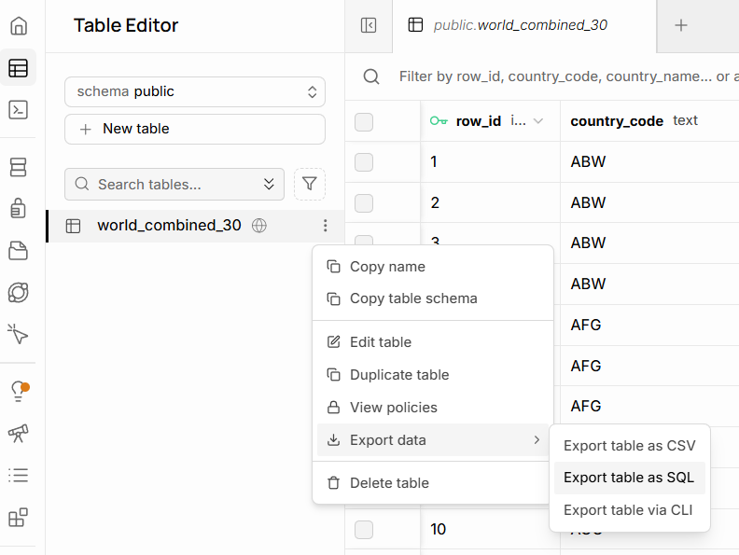

Start running these SQL queries:

Basic selection and filtering
List distinct countries in the table:

SELECT DISTINCT country_name
FROM world_combined_30;

Provided a list of all countries

Show all languages for Angola, ordered by percentage (highest first)

SELECT language,
language_percentage
FROM world_combined_30
WHERE country_name = 'Angola'
ORDER BY language_percentage DESC

Ovimbundo being top of the list for language percentage 37.2

Find all countries where English appears as a language

SELECT DISTINCT country_name,
country_code
FROM
WHERE language = 'English';

I put a ; after DESC from previous query and then entered world_combined_30 into the FROM

Show all non-official languages for Albania

SELECT language,
language_percentage
FROM world_combined_30
WHERE country_name = 'Albania'
AND is_official = ;

The official column stores True/False or Yes/No so adding 'f' after the last = provided the data. Top one being Greek 1.8

List countries whose population is between 100,000 and 3,000,000

SELECT DISTINCT country_name,
country_population
FROM world_combined_30
WHERE BETWEEN 100000 AND 3000000
ORDER BY country_population;

We need Country_Population after the Where to show where want the data from

Aggregation per country
Count how many language rows each country has in DESC order

SELECT country_name,
COUNT(*) AS language_count
FROM world_combined_30
GROUP BY country_name
ORDER BY language_count ;

We need to add DESC after language_count otherwise the Order by won't work. Top one being Angola with 9

Show the maximum language percentage per country

SELECT country_name,
MAX(language_percentage) AS max_language_percentage
FROM world_combined_30
GROUP BY country_name
ORDER BY DESC;

Find countries where at least one language has more than 50% share

SELECT DISTINCT country_name
FROM world_combined_30
WHERE language_percentage > 50;

For each country, show the total percentage of official languages

SELECT country_name,
SUM(language_percentage) AS total_official_percentage
FROM world_combined_30
WHERE is_official =
GROUP BY country_name
ORDER BY total_official_percentage DESC;

List countries that have more than one official language

SELECT country_name,
COUNT(*) AS official_language_count
FROM world_combined_30
WHERE is_official = TRUE
GROUP BY country_name
HAVING COUNT(*) > ?
ORDER BY official_language_count DESC;

Combining filters and aggregates
Show official languages where the percentage is under 10%

SELECT country_name,
language,
language_percentage
FROM world_combined_30
WHERE is_official = TRUE
AND language_percentage ;

Find the country where Arabic is official

SELECT country_name,
country_code,
language_percentage
FROM world_combined_30
WHERE language = ' '
AND is_official = ;

For each country, show the number of non-official languages

SELECT country_name,
COUNT(*) AS non_official_count
FROM world_combined_30
WHERE is_official =
GROUP BY country_name
ORDER BY non_official_count DESC;

List all rows where the city name contains the word ‘la’ (case-sensitive)

SELECT *
FROM world_combined_30
WHERE city_name LIKE '%%';

Show countries whose most spoken language (max %) is not official

SELECT country_name
FROM world_combined_30
WHERE language_percentage = (
SELECT MAX(w2.language_percentage)
FROM world_combined_30 AS w2
WHERE w2.country_name = world_combined_30.country_name
)
AND is_official = ;

Subqueries:

List countries with population above the overall average population

SELECT DISTINCT country_name,
country_population
FROM world_combined_30
WHERE country_population >
(
SELECT AVG()
FROM world_combined_30
);

Show languages that are official somewhere and have ≥ 40% in that country

SELECT DISTINCT language,
country_name,
language_percentage
FROM world_combined_30
WHERE is_official =
AND language_percentage >=

ORDER BY language;
Find countries whose total percentage of all languages is < 100 (data quality check)
Drag selected lines of code and then run, if need be.

SELECT country_name,
SUM(language_percentage) AS total_language_share
FROM world_combined_30
GROUP BY country_name
HAVING SUM(language_percentage) <
ORDER BY total_language_share;

Show rows where the city appears in a country with more than 5 languages
Drag selected lines of code and then run, if need be.

SELECT *
FROM world_combined_30 AS w
WHERE country_name IN (
SELECT country_name
FROM world_combined_30
GROUP BY country_name
HAVING COUNT(*) > ?
);

Course Notes

It is recommended to take notes from the course, use the space below to do so, or use the revision guide shared with the class:

Additional Information

We have included a range of additional links to further resources and information that you may find useful, these can be found within your revision guide.

END OF WORKBOOK

Please check through your work thoroughly before submitting and update the table of contents if required.

Please send your completed work booklet to your trainer.

